Part 5, Aggregate Functions & Grouping

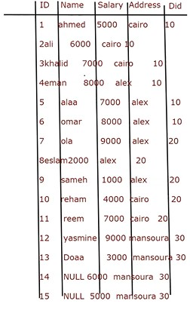

Aggregate Functions

* Like 🡺 Count, Max, Min, Avg, Sum
  + Select Count (Salary) From Employee
    - 15
  + Select Sum (Salary) From Employee
    - 1000000
  + Select Max (Salary), Min (Salary)
    - 9000, 1000
  + Select Count (*), Count (ID), Count (Name) From Employee **(Null values not counted)**
    - 15, 15, 13
  + Select Avg (Salary) From Employee
    - Sum and Divide on number of not null values.

Grouping

* Select Min (Salary), Did From Employee Group By Did
* Select Count (ID), Address From Employee Group By Address